Map of Africa
from Kenneth Cressman

Handcrafted map of Africa is from Burkina Faso. February 2011, Kenneth participated in a Mennonite Church Canada Learning Tour to Burkina Faso. It was an opportunity to experience the life and witness of a developing Church community which is supported by MC Canada.

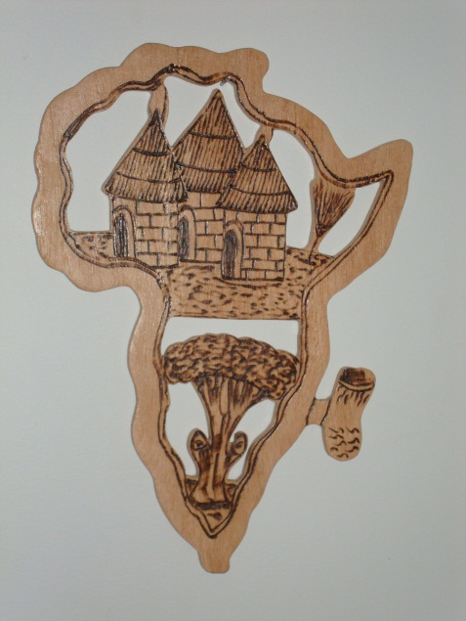

Kenneth was intrigued with the workmanship that went in to producing something as intricate as the map--only an outline but with some features added suitable to African life. As a former geography teacher anything related to a map appealed to him and he made the purchase. The map is a tangible way for us to be mindful of our African brothers and sisters.

Wall Hanging
from Dana Fretz

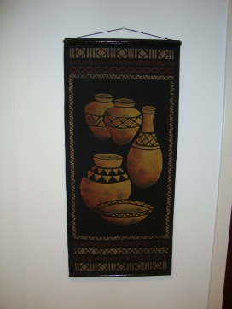 The wall hanging is from Zimbabwe. In 2003, Dana was a part of the MCEC group who participated in Mennonite world conference gathering in Bulawayo, Zimbabwe. The hanging was given to the church by Dana as she shared of her experiences in worship and said thank you to the church for their financial and prayerful support.

Jesus Statue
from Mary Anne Cressman Musser

Statue is from Lithuania where Mary Anne was on a study abroad term (2001-2002) through Canadian Mennonite University and again with the Eastern Mennonite Missions YES program in 2003-2005.

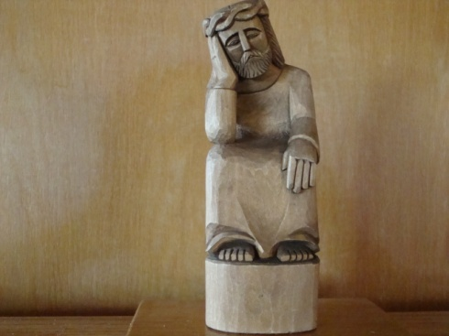

The "crying Jesus" figure is unique to Lithuanian (Catholic Church) culture because of the hardships the country has gone through. Jesus understands and is weeping with them. Mary Anne thought this was an appropriate representation of Lithuania and something interesting to share with the church.

“Today God Spoke my Name”
by Gladys Cressman

Banner was created for the service of ordination for Matthew and Hendrike Isert Bender on Sunday September 26, 2004. The words of taken from Isaiah 43:1.

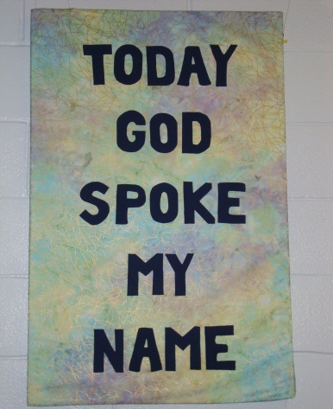

God loves us, gifts us and calls each of us by name, to follow and to love others as God has loved us.

“Tree beside the river” and “life flows on”
By Chris Cressman

The banners were digitally created by Chris Cressman to hang in the front of the sanctuary when there is no other banners being used relating to a specific theme. They were hung for the first time September 2007.

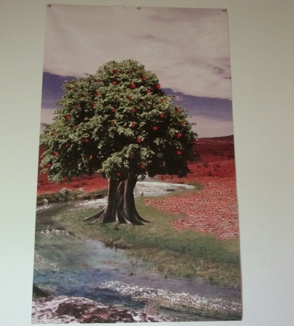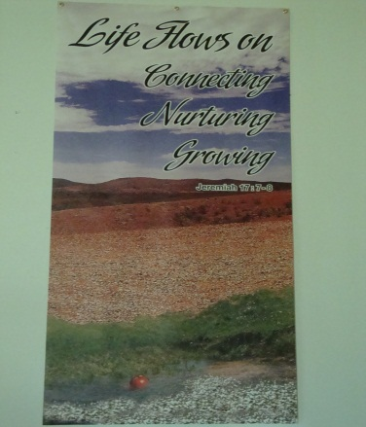

The idea for the banners emerged from a church retreat on February 23-25, 2007 entitled Approaching God’s Feast. The retreat was guided by two scriptures Jeremiah 17:7-8 and Psalm 63:1-5a from which the banner themes emerged.

Peace Banner
By Gladys Cressman

This wall hanging was created as a way to process the terrifying experience of 9/11.
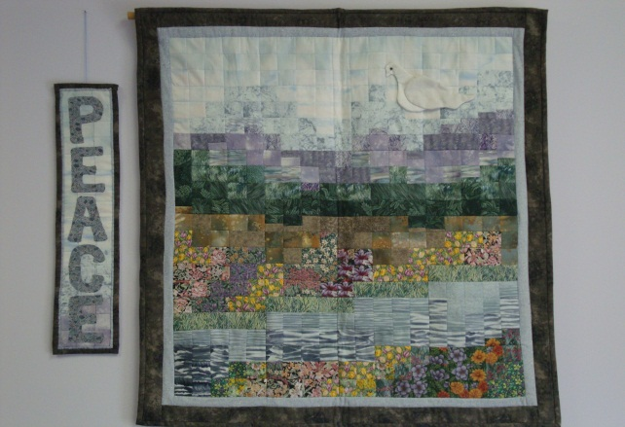

It is a statement of hope and confidence in the way of Peace over the way of violence.

Clock and Light Fixtures in Sanctuary.
By Willard Cressman,

During Willard and Beulah’s time as church custodians, Willard shared his creative talents with the church by making the clock and light fixtures which hang in the sanctuary. They continue to serve a functional purpose but also add beauty and personal touch to the Nith Valley worship space.

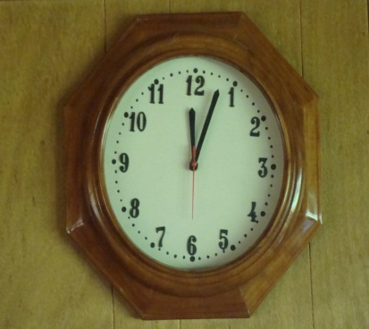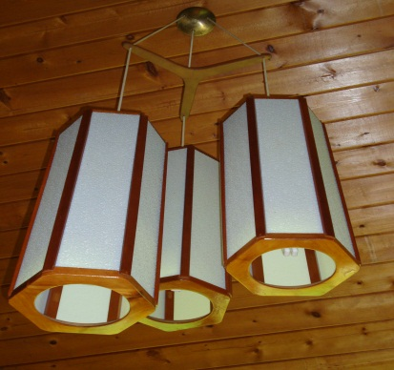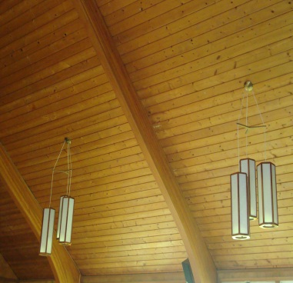
Chair/step ladder
By Zenas Snyder, early 1900’s

Zenas Snyder made this simple multi-purpose chair/step ladder. It sat in the original Biehn church under the clock recalls his daughter Beulah Cressman. This century old item is a concrete physical connection to people and memories of the past which presently sits at the back of the Nith Valley Sanctuary.

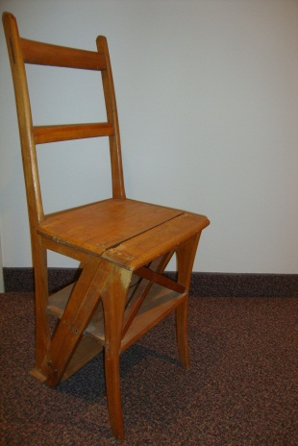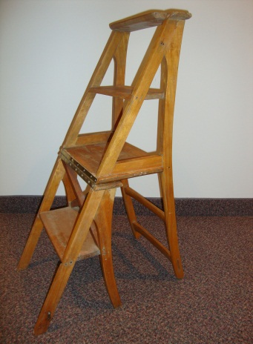

'Crimson King' maple tree from Stephen Hoke, Mother’s day 1986

On the occasion of the Mennonite bicentennial and in Honor of the 'Mothers of Nith Valley", the 'Crimson King' maple tree located on the south-east corner of the church property was given to Nith Valley by Stephen Hoke.

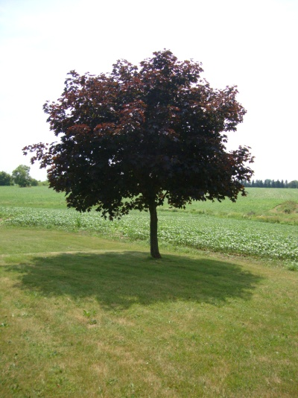
As this tree grows through the changing of the seasons, year after year, it continues to witness to the enduring faith and presence of Mennonites in Canada and the strength of a mother’s love for her children.

A New Life
By Cheryl Good, 1996

This piece was commissioned by the sewing circle with funds donated by Gladys Cressman in memory of her husband Clayton. This work is based on the words of the Apostle Paul in Romans 6:4b. New life is depicted in the new tree growing from the old stump and in the life of the infant, through youth and maturity to older adulthood. The dark sky of early life may represent the concerns and uncertainties of human life, giving way to the subdued light of faith and trust in God and finally to brilliant light as eternal life is anticipated.

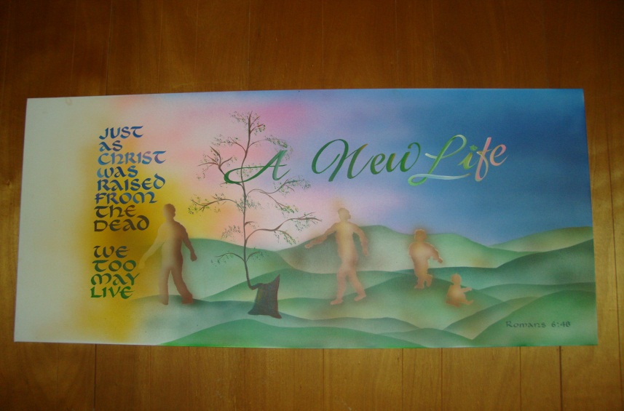

Wait … be renewed
By Hank Bos, fall 1981

‘Wait … be renewed’ takes its title from Isaiah 40:29-31. This passage refers to the renewal of strength that comes from the Lord. For Christians, the three trees represent the new life that has come because of Golgotha. The eagle tends its young in the nest with strength and vigor and thus gives strength to its young. So, we too, are given strength and sustenance in the living Christ.

